6 Engineering Consultants

M/s AKMEC GROUP offers Engineering and Technical consultant to various customers, industries, manufactures and cross country business houses dealing in purchasing and selling of products internationally. Our scope of engineering consultant work covers following sections.
ASSET INETRGRITY ENGINEERING
& TECHNICAL SOLUTIONS

- Corrosion Loop Development and Marking
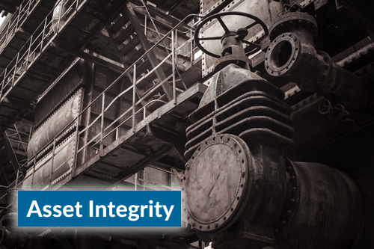
- Damage Mechanisms Identification
- CML Identification and Optimization
- Injection and Mix Point Assessment
- Dead Leg Identification and Risk Ranking
- Corrosion Control Document (CCD)
- Risk Based Inspection (RBI) Study
- Develop Inspection Scope and Technique

- Inspection Data management and Automation
- Asset Integrity Management System
- Isometric, P&ID and PFD Drafting
- Asset Life Extension Study
- Fitness for Services (API 579/ASME)
- Assessment of UG/Cross county Pipeline
- Study of Online Corrosion Probes and Coupon
- Root Cause Analysis (RCA)/Remaining Life Assessment (RLA)
- Analysis of Industrial Failure, Delivering Effective Remedies
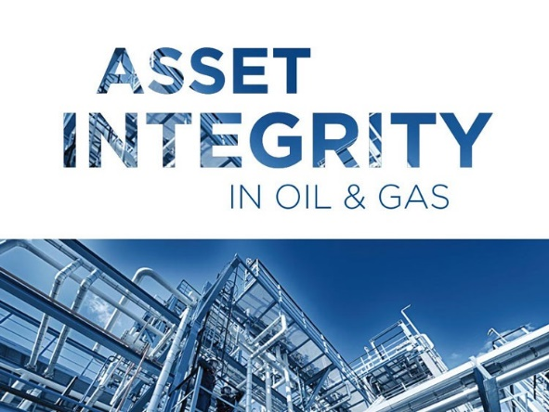
- Assessment of Small-bore piping/critical Equipment

